

Year 7 Science 2019
Physics 1 Test

SECTION 1: MULTIPLE CHOICE (1 mark each)
Circle your answers in the section on page 3.

- Which of these is not a type of force?
  - Push
  - Pull
  - Twist
d) Heat

- Which is true about magnets and the way their forces act?
  - Magnets can act over a distance or in contact with an object.
  - Magnets can only act over a distance.
  - Magnets can only act in contact with an object.
  - Magnets can not act over a distance or in contact with an object.

- Which of the diagrams below shows a correct alignment of magnets?
a)  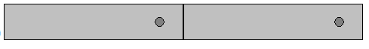 | b)  
c)   | d)  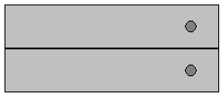

- Friction is a type of
  - force.
  - weight.
  - energy.
  - gravity.

- How do simple machines give a mechanical advantage when lifting an object?
  - They allow less work to be done, but over a greater distance.
  - They allow less energy to be used over a smaller distance.
  - They allow less force to be used, but over a greater distance.
  - They allow the same force to be used over a smaller distance.

- Screws, ramps and stairs are all examples of
  - levers.
  - incline planes.
  - wheels and axles.
  - pulleys.

- Which of these is an example of a wheel and axle?
  - Scissors
  - See-saws
  - Jack
  - Door knob

- The diagram below shows different pulley arrangements.
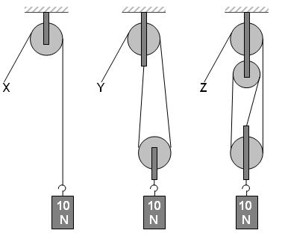
Which of the following statements is correct about the above diagram?

- Force X, Y and Z are all equal.
- Force X would be equal to 10N.
- Force Y would be equal to 10N
- Force Z would be equal to 30N

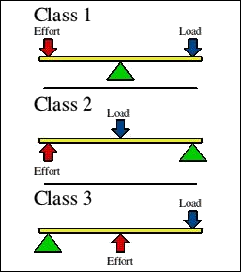

- Study the chart to the right:

Which of the following diagrams shows a Class 2 Lever?
a)  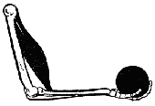 | b)  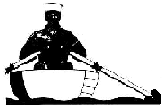 | c)  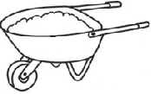 | d)  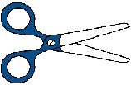

- A wheel and axle is a part of a
- incline plane
- lever
- pulley
- gear

Year 7 Science 2019
Physics 1 Test

Name:

Multiple choice answer section.

Circle your choice:

- A B C D

- A B C D

- A B C D

- A B C D

- A B C D

- A B C D

- A B C D

- A B C D

- A B C D

10. A B C D

Multiple choice mark: /10

Short answer mark: /25

Total: /35

SECTION 2: WRITTEN
Write your answer in the spaces provided

- Classify each of these forces as contact or non-contact (4)
(write n or c for each on your answer sheet)

- Magnetic __________

- Friction _________

- Gravity ________

- Collision _________

- What is the reading on each of the spring balances shown below? (4)
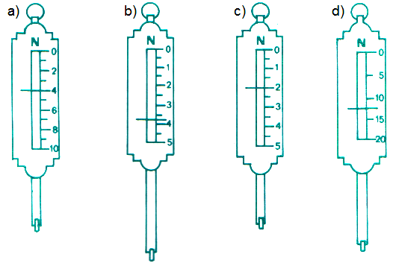

___________ ___________ ____________ ____________

- Explain why levers, inclined planes, gears, wheels and axles are called “machines”. (1)

_________________________________________________________________

_________________________________________________________________

_________________________________________________________________

- What type of simple machine is shown in each diagram? (4)
a)  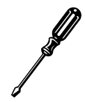  _____________________ | c)  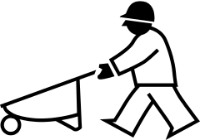  ____________________
b)  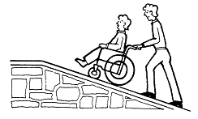  _____________________ | d)  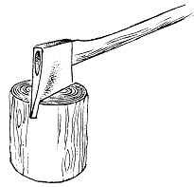  _____________________

- Levers can be used to make lifting easier by producing a greater force (2)
- How can you increase the force?

________________________________________________________

________________________________________________________

- What must you do more of?

________________________________________________________

________________________________________________________

- The three simple machines below are all types of levers.
Identify the fulcrum (f), effort (e), load (l) in each case. (6)

\

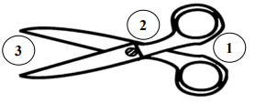
- __________________
- __________________
- __________________

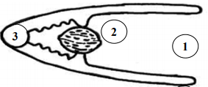

- __________________
- __________________
- __________________

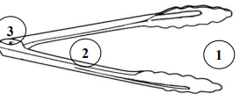

- __________________
- __________________
- __________________

7. Determine whether the object forces are balanced or unbalanced by circling one. (4)
a) Balanced / Unbalanced
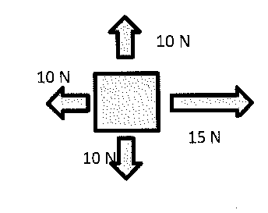
b) Balanced / Unbalanced
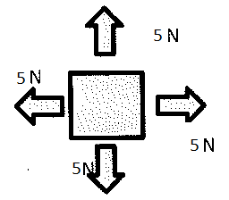
c) Balanced / Unbalanced
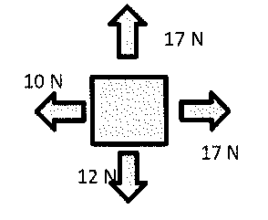
d) Balanced / Unbalanced
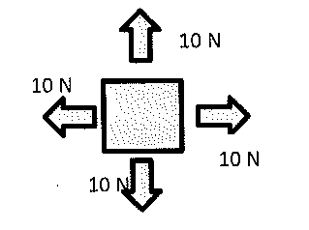
END OF TEST (OUT OF 35 MARKS)

